SWE20001 – Development Project 1: Tools and Practices

Distinction Task <11.1D>

Duy Phuong Nguyen (101204984)

Lab: Friday 2:30pm

Tutor: Huai Liu

Team number: 3

Henry Tran 102075482

Edward Knight 102700043

Duy Phuong Nguyen 101204984

# Custom project SWE20001 – Exercise club website

## An overview introduction and summary of the project and its achievements or outcomes, in particular during your involvement

For the group open project, our group came up with an idea of a website which is called “Exercise club website”. It is a tool for everyone to find gym mates, gym session and helpful information for their work out session, such as: gym location, guide, discount, and coupons. We tried our best to create a friendly-user interface with lots of unique function and features. It helps our product stand out from the market and competitors.

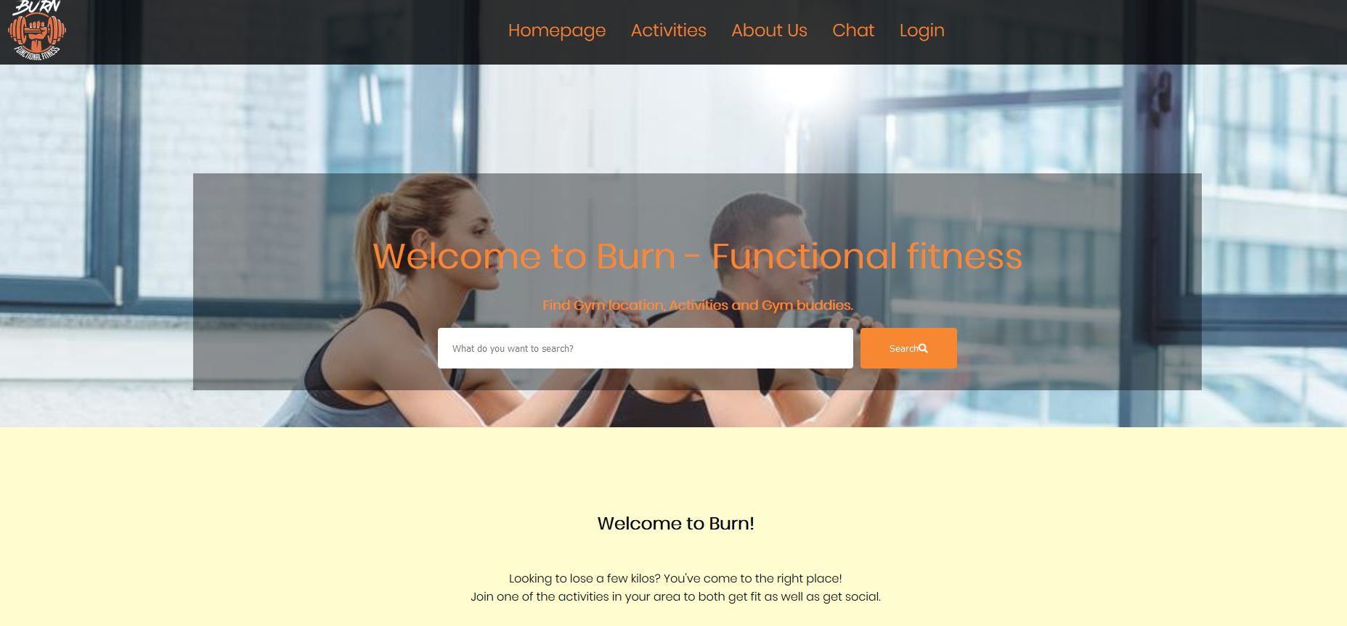

For example, if you want to find or search any information you can simply use our search bar.

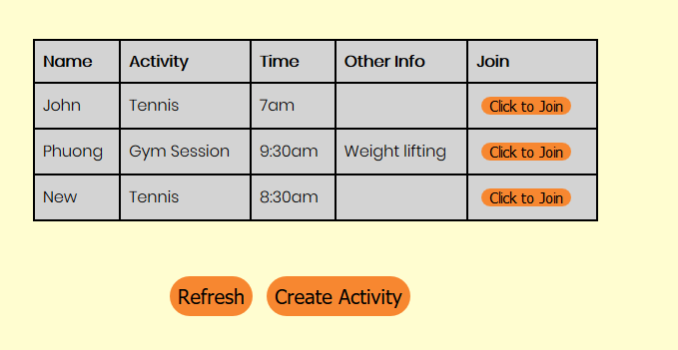

You can also find and join workout session which is created by another users. You can create a new one with free of charge. The login function is provided, and all the information are stored securely in our database.

Our website is built with HTML, CSS, JavaScript and PHP and MySQL database. Our group leader and developer write the code from scratch using DAD development process and TDD process. We have 4 iterations stages and one final presentation to introduce our product.

## A summary account of your contribution to the project, using appropriate visualization and measurements, including the definition and justification for any measures used

1. Week 1(17/4/2020): Our team leader Henry created a vision board on Google drive and our team decide what is our project look like.

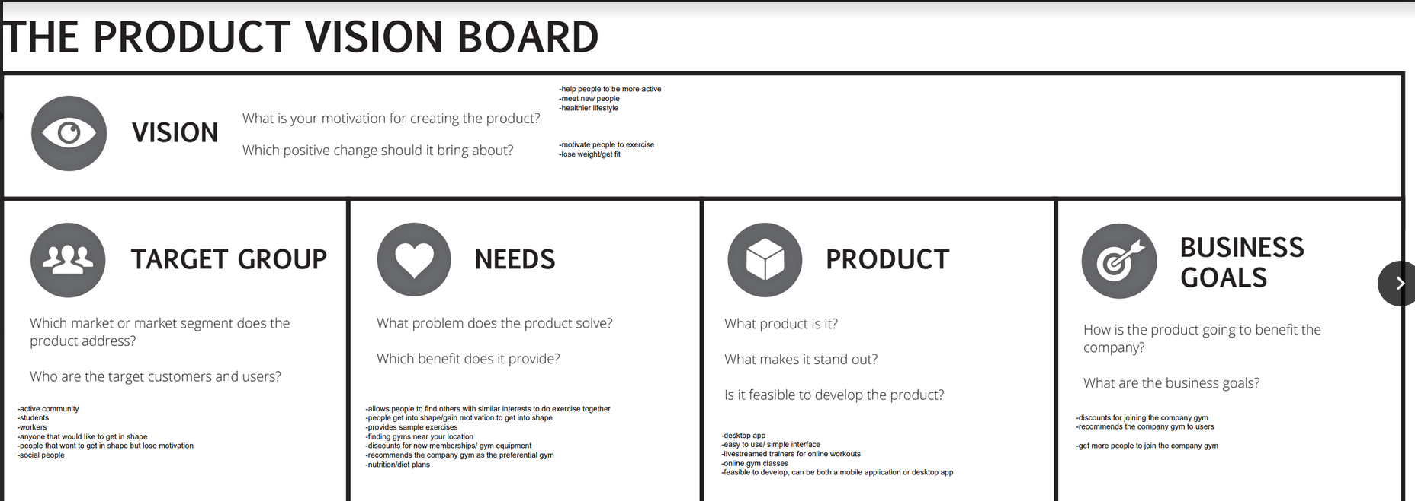

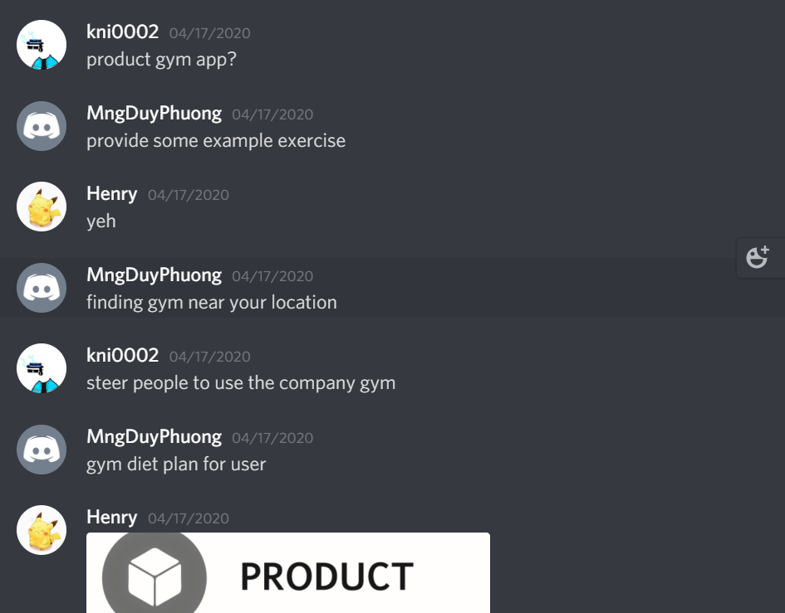

I joined the discussion and provide some ideas. Our group decides to create a C# apps for user to use on their computer.

We then split the project vision document. There are 10 parts and we have 3 members so each of us get 2 parts and the next week we will split the rest. I got 6 and 7 which are ‘Release plan’ and ‘Risk’ respectively.

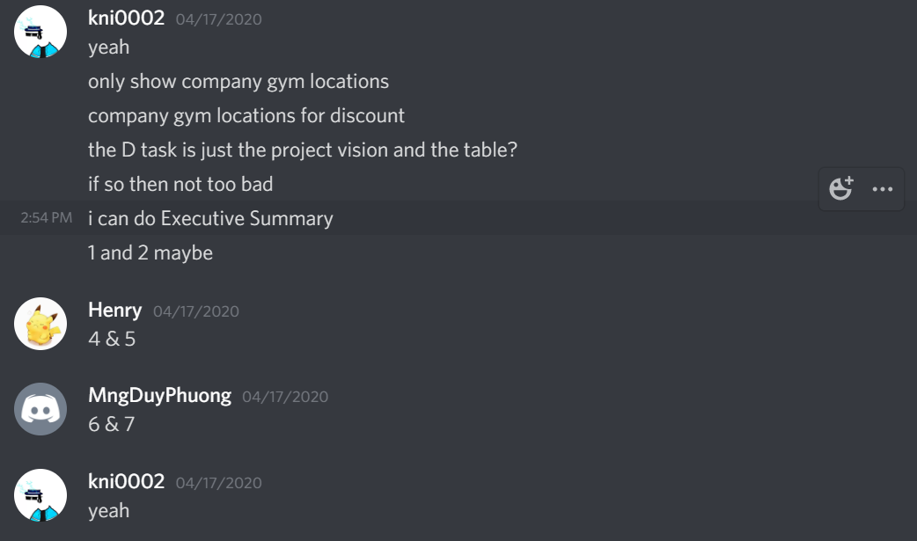

My contribution in Vision document

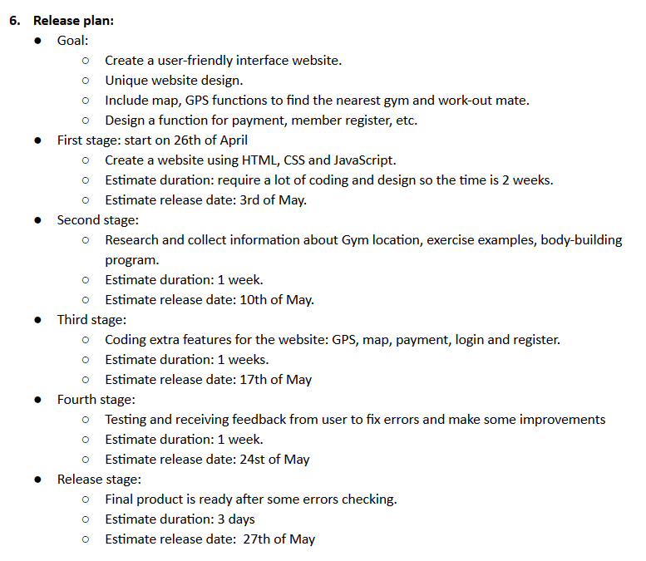

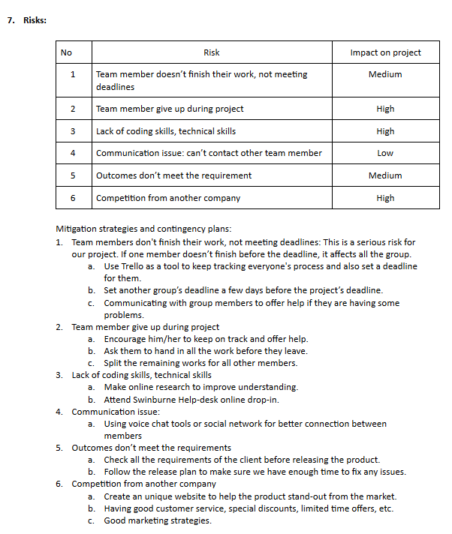

Next meeting is set to Tuesday next week (21/4/2020) so we can split the rest of document and complete the task on time.

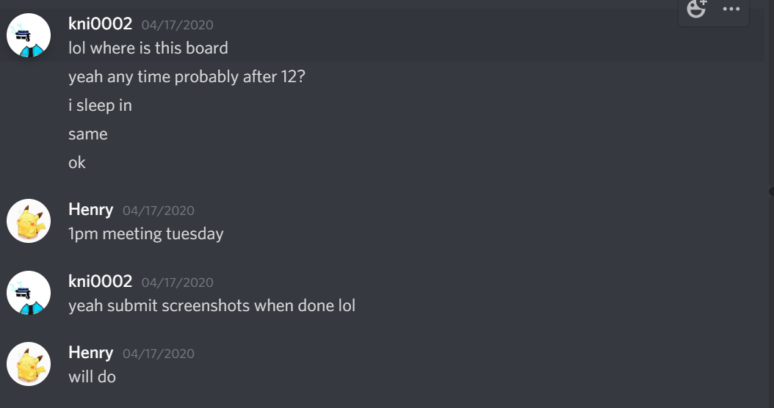

1. Week 2 (start on 20/4/2020):

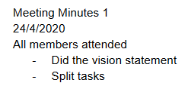

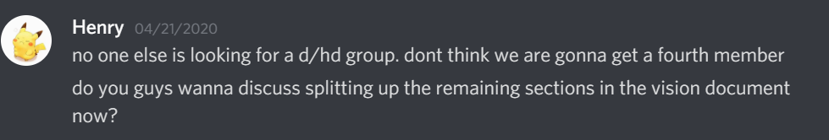

Our group has only 3 members, so I suggest my leader to find one more member, so it is easier for us to create more quality product during the project. However, there is no one finding to join D/HD group.

We finish and finalise the vision document. This is my contribution to the document this week.

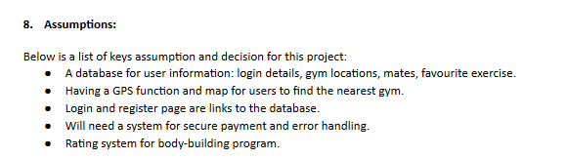

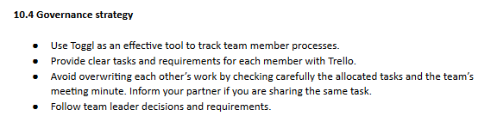

Link to our Group vision document: <https://drive.google.com/file/d/1b_vREMBqHHSxAQy3J5YZ5BWL784lLwfn/view?usp=sharing>

After that, our group decided our role in this project: 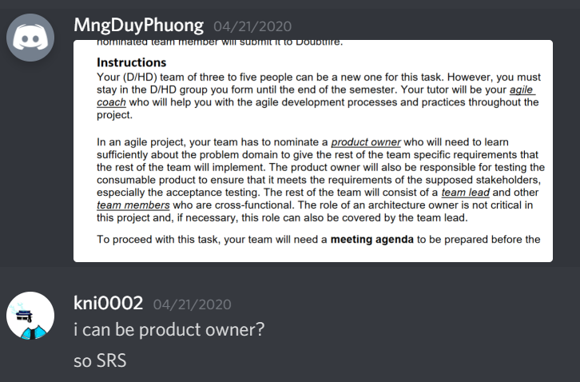

Edward is the product owner, Henry is group leader and I will be team member, so I will mainly do the coding and designing our product.

Because our group is only 3 members, so I decide to ask my group to swap our project from C# language into Website. All of members are agreed to this idea.

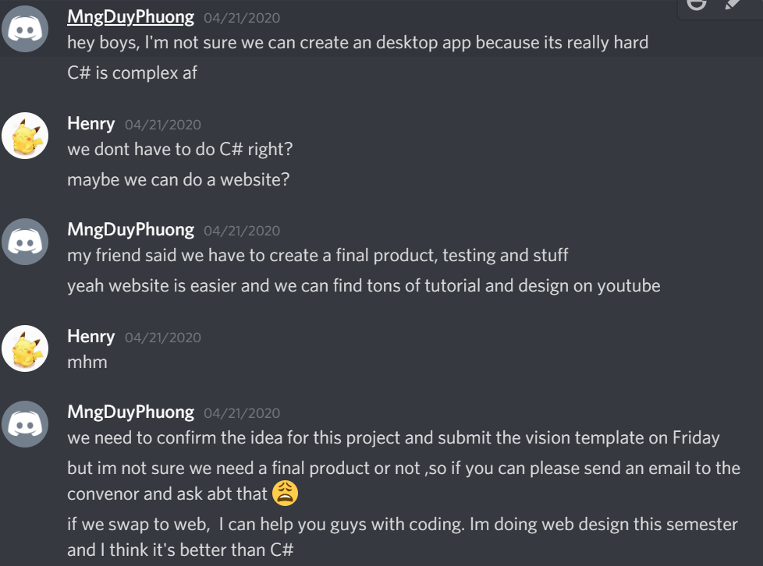

1. Week 3 (start on 27/4/2020)

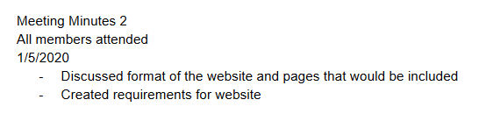

Since Edward is the product owner so me and Henry asked him to provide us an SRS as soon as possible but Edward forgot about it. Me and my team leader must create a simple list of essential items to start working on the project without the SRS.

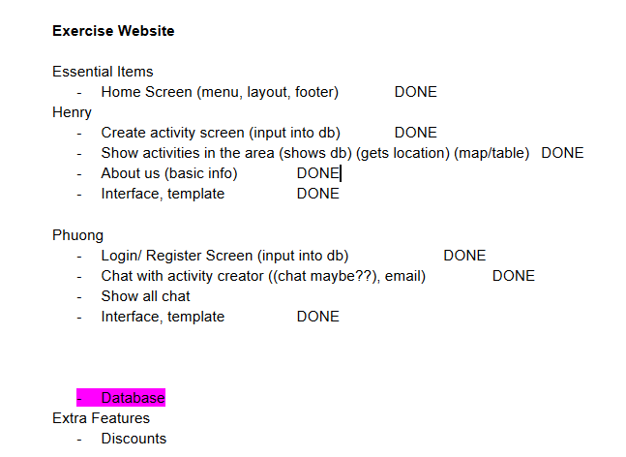

Henry tried to create a layout for our group project by creating a homepage.

We split the task from the beginning to avoid any conflicts and duplicates.

1. Week 4 (start on 4/5/2020)

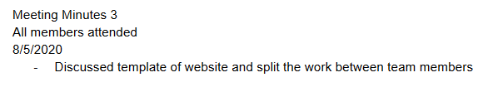

Henry sent his work on the project. 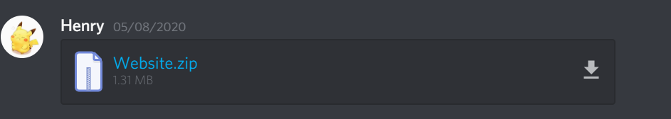

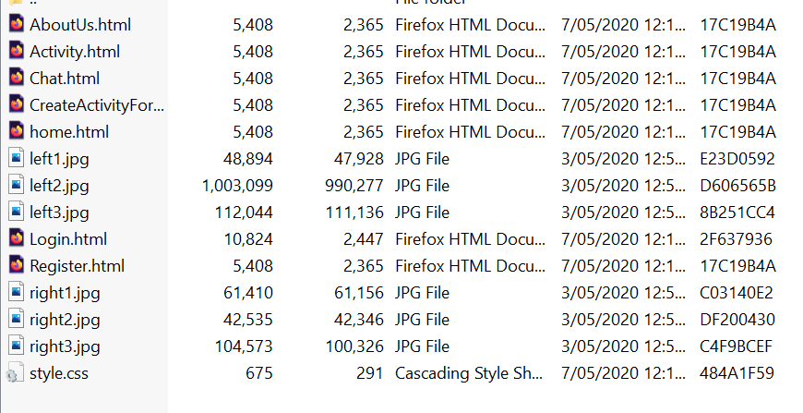

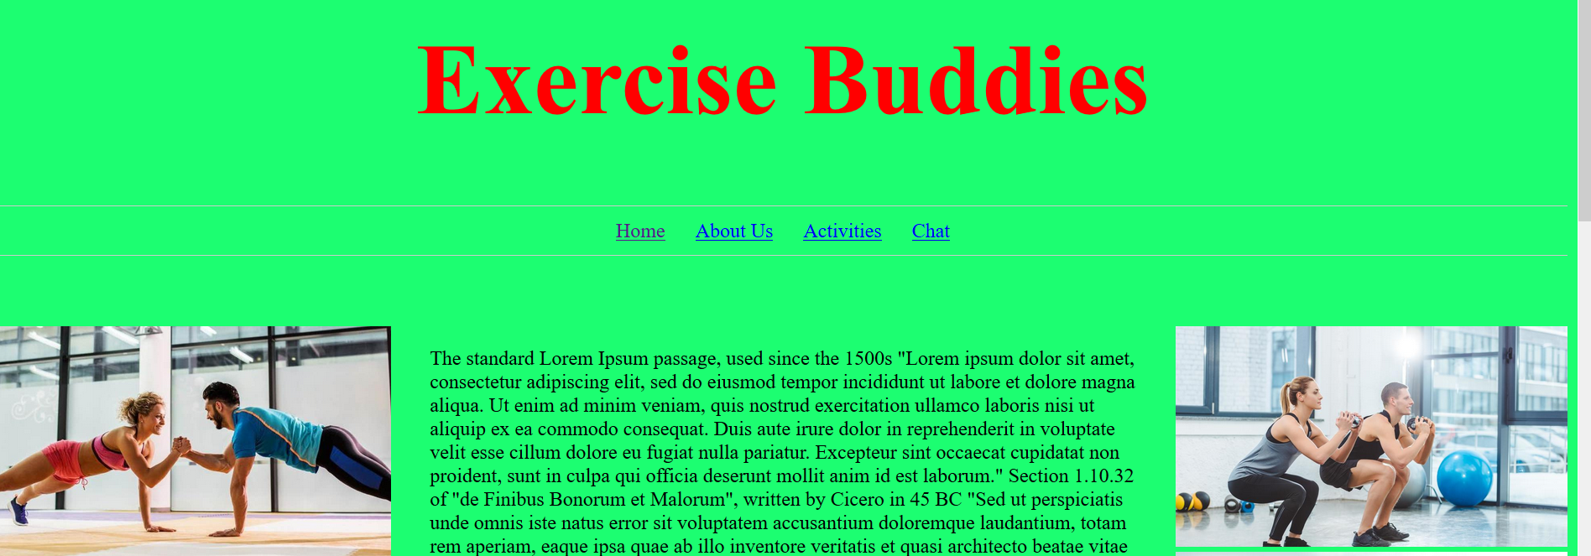

I think I could make it looks better and make the project cleaner by ordering all the file into specific folder. So, I tell them to give me time to fix the code and I will submit it next week.

I finished my work during weekend, it is earlier than expected so I asked my friend to check it and we have more time to finish the project.

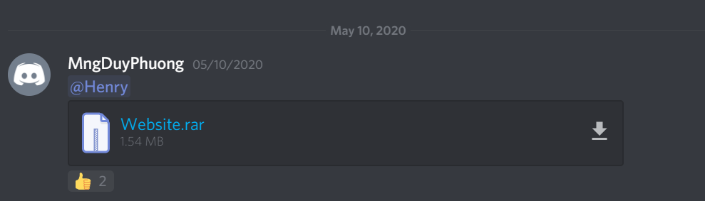

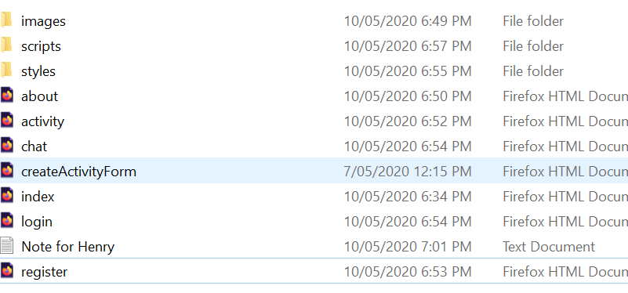

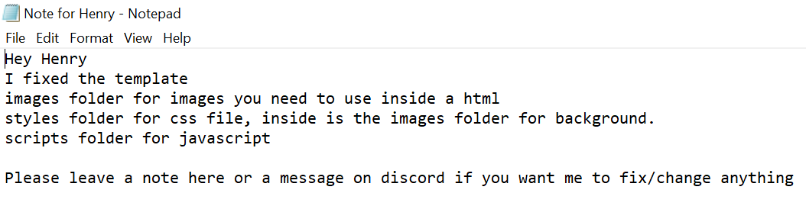

Index homepage with search function, its has been tested with TDD process.

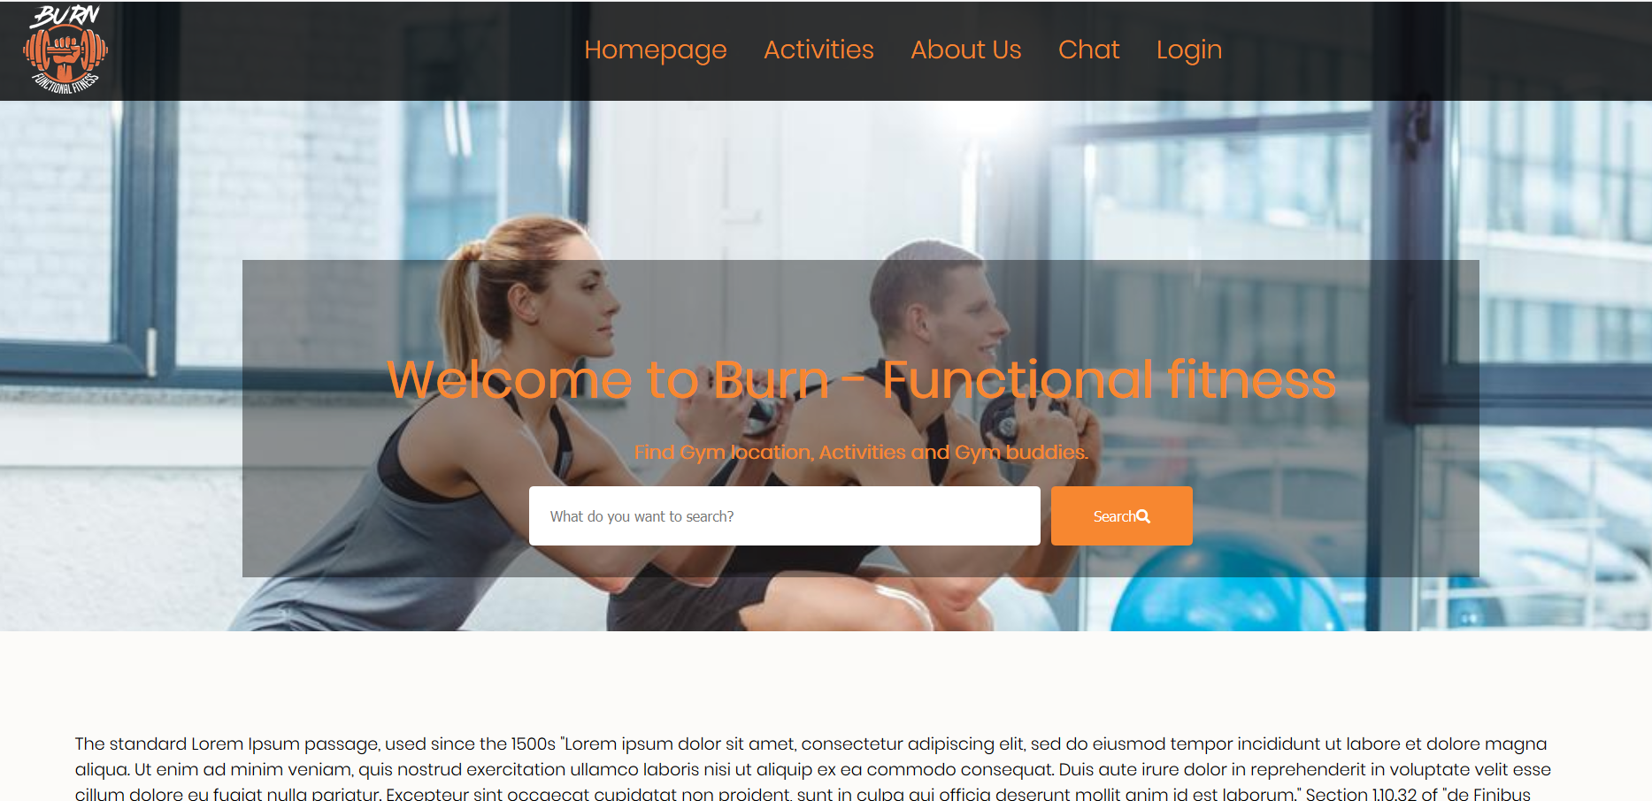

Other pages in our project.

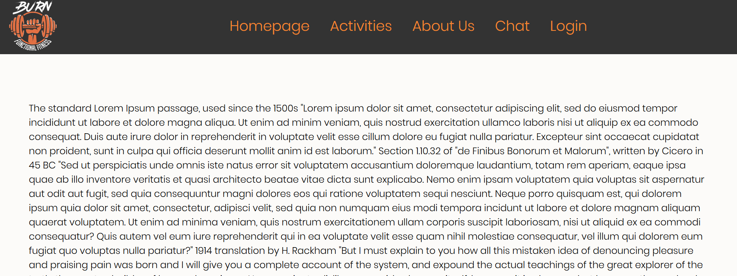

I made a small note for my team leaders so he can easily to understand what is going on and contribute his work.

Code for template of project.

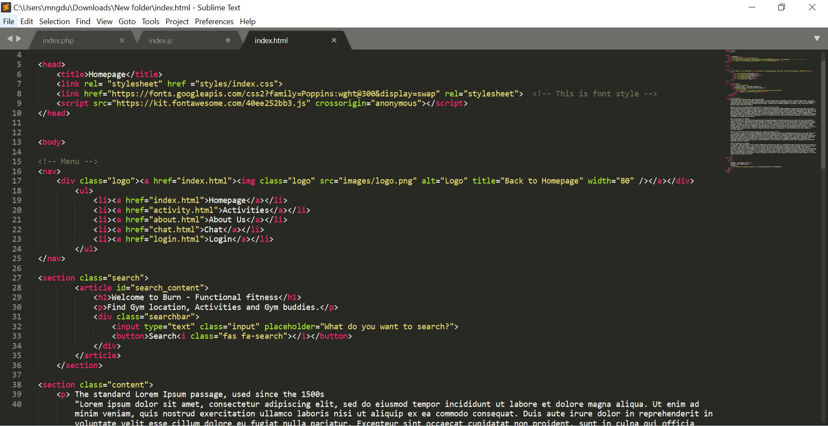

Mark up using CSS

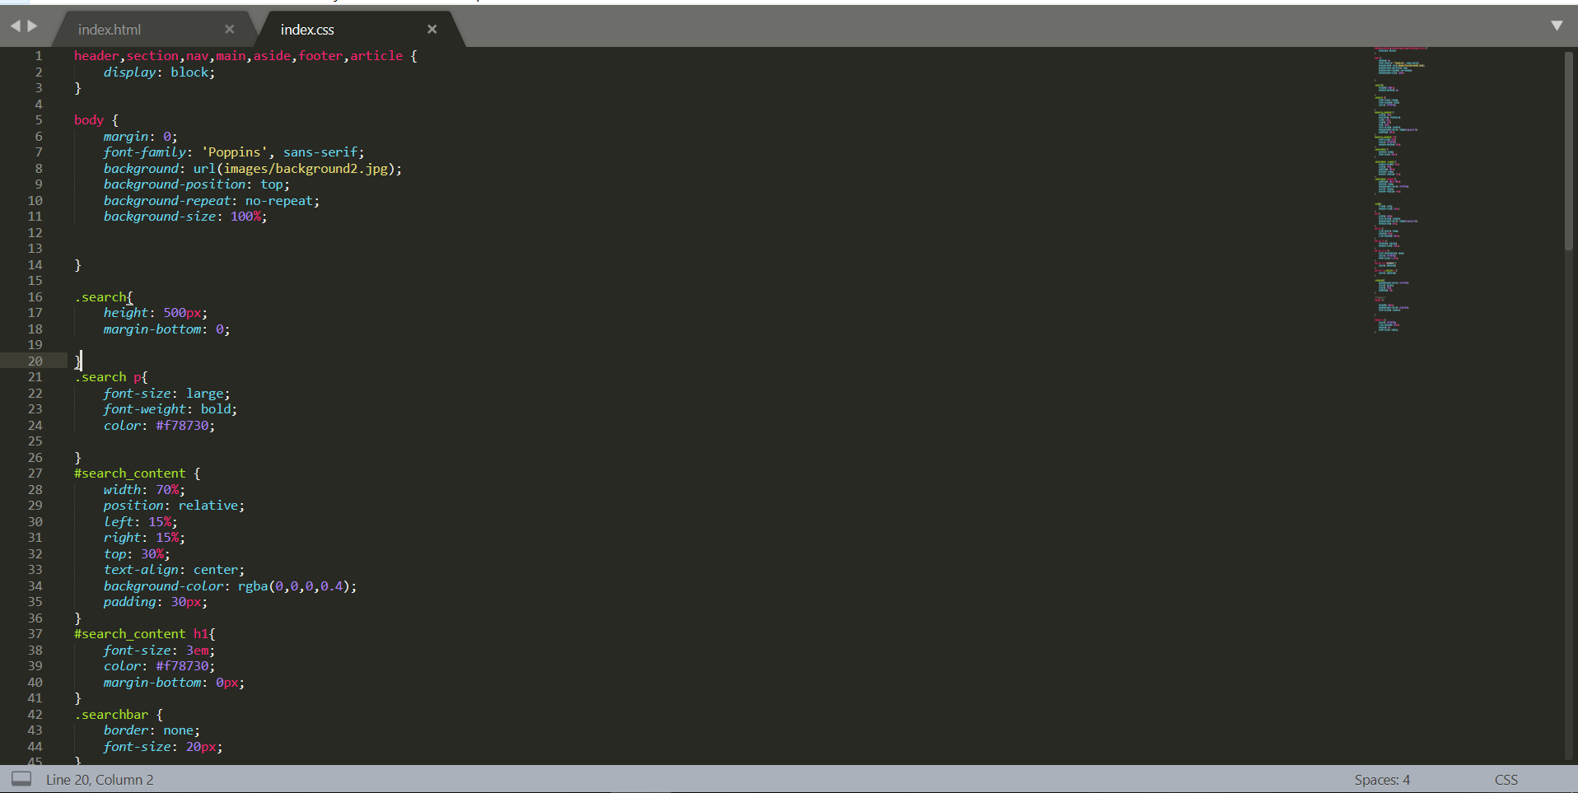

So we finished our first iterations: Skeleton of the website (essential items, tasks splitting)

I’m also asked my teammate to use GitHub to upload, merge our project from the beginning. However, they refused and said we can just send everything through discord channel.

1. Week 5 (start on 11/5/2020)

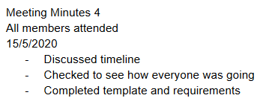

Me and Henry start working on the database of our project so we can store our customer information.

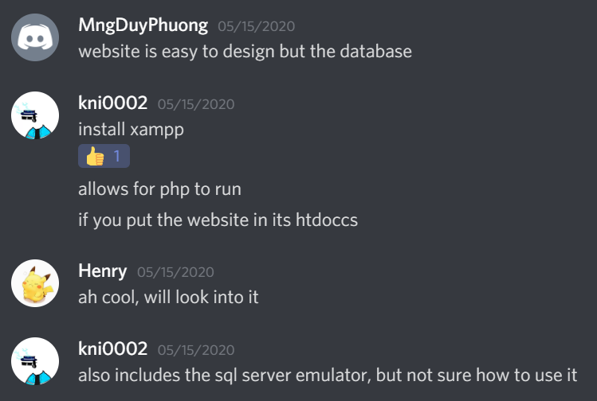

1. Week 6 (start on 18/5/2020)

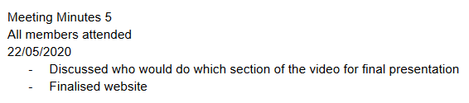

I sent them my works which are login, signup page and chat page on 21/5/2020

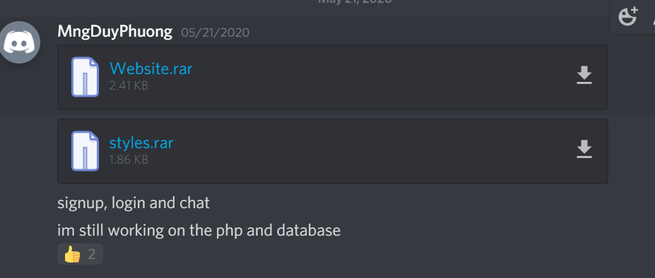

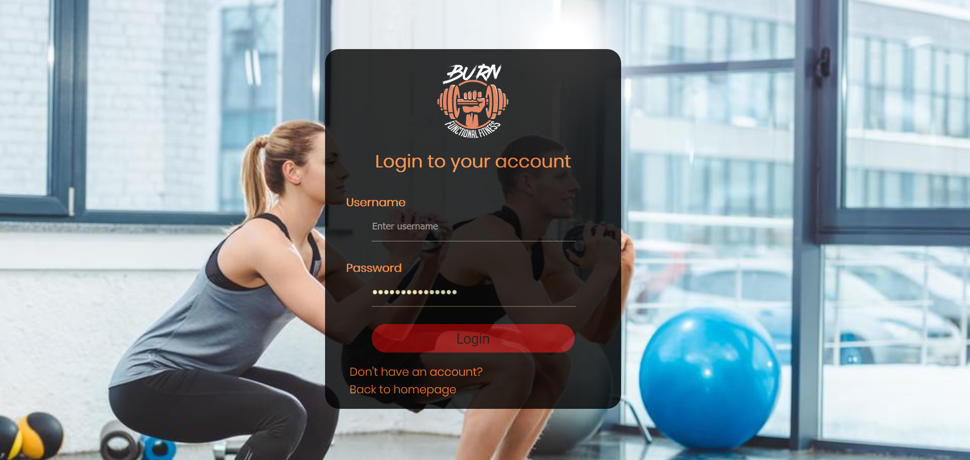

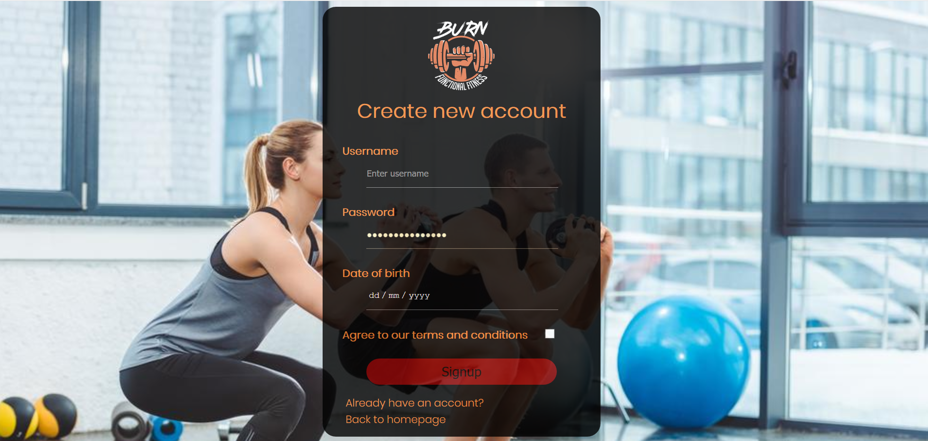

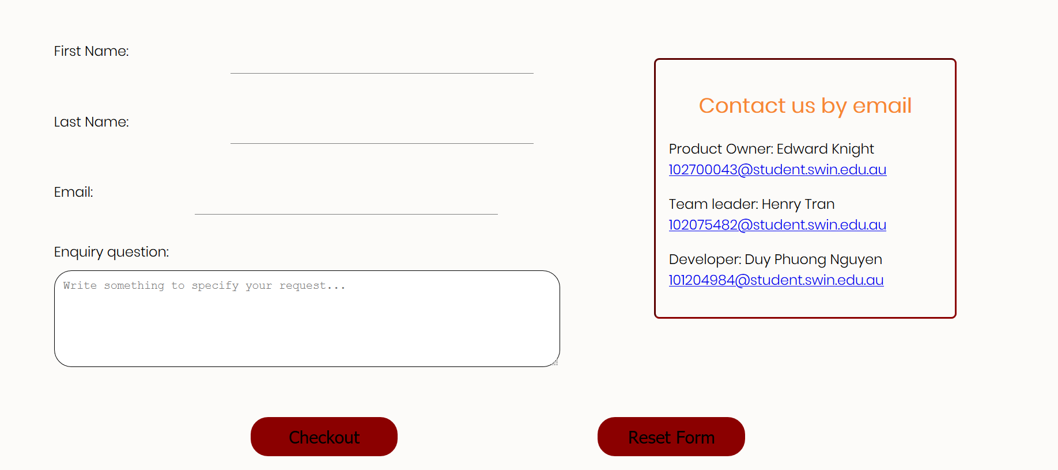

Because there are only 2 members do the coding, so the workload is quite heavy for me. I tried to finish the project as soon as possible so we can demonstrate our project during presentation.

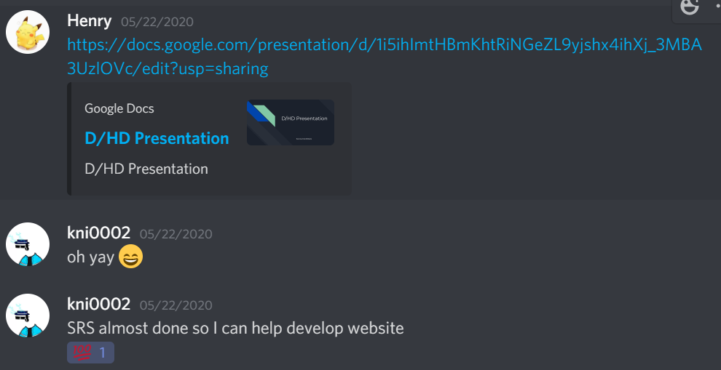

We created the PowerPoint slides on google drive so members can contribute and design their part. Below are my slides

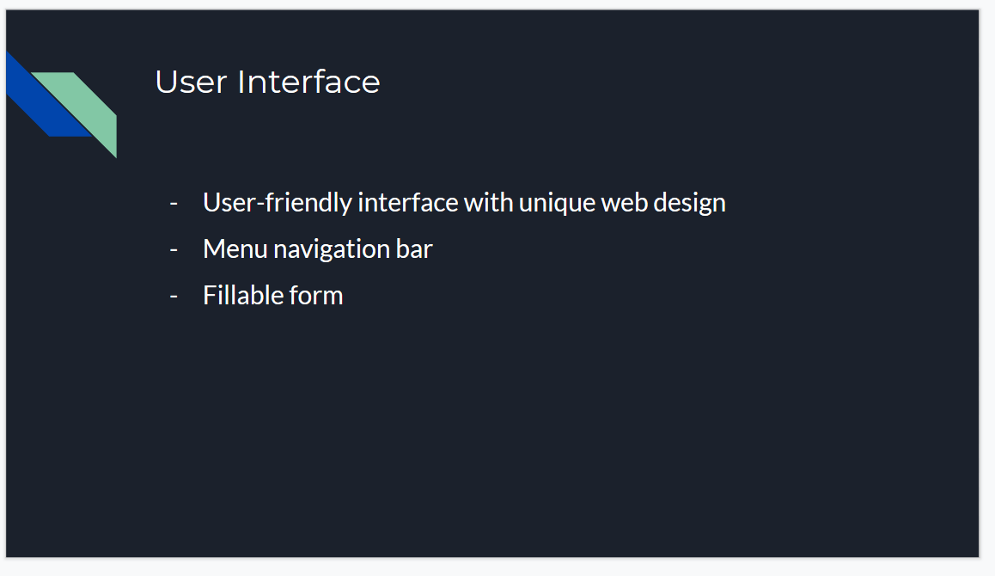

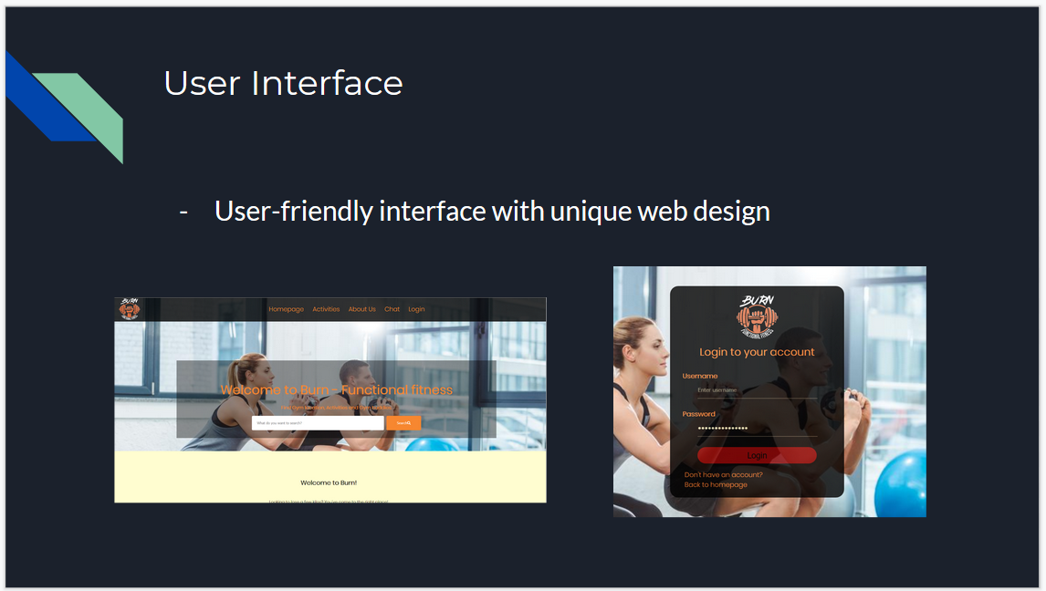

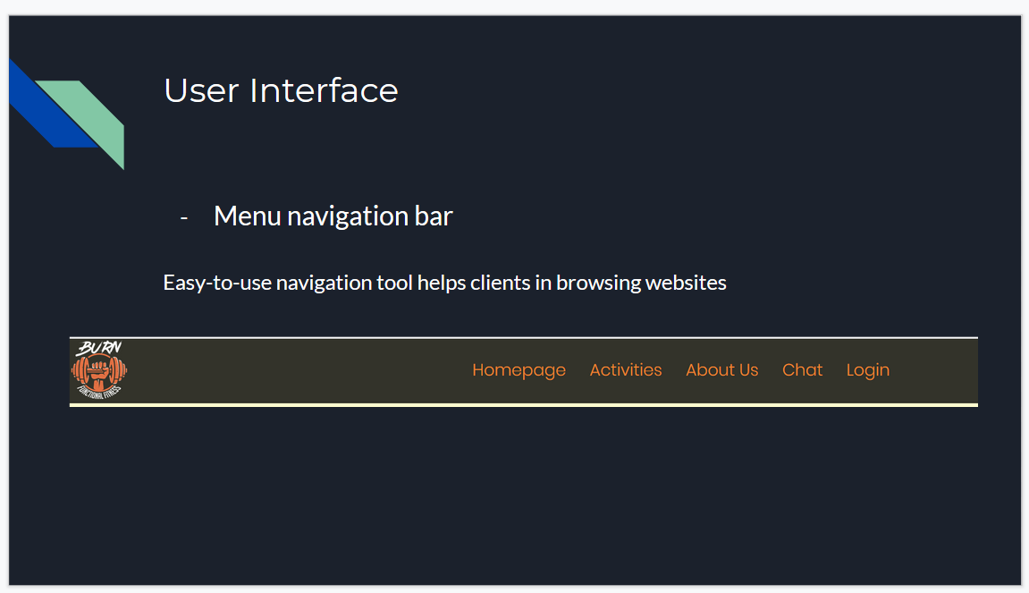

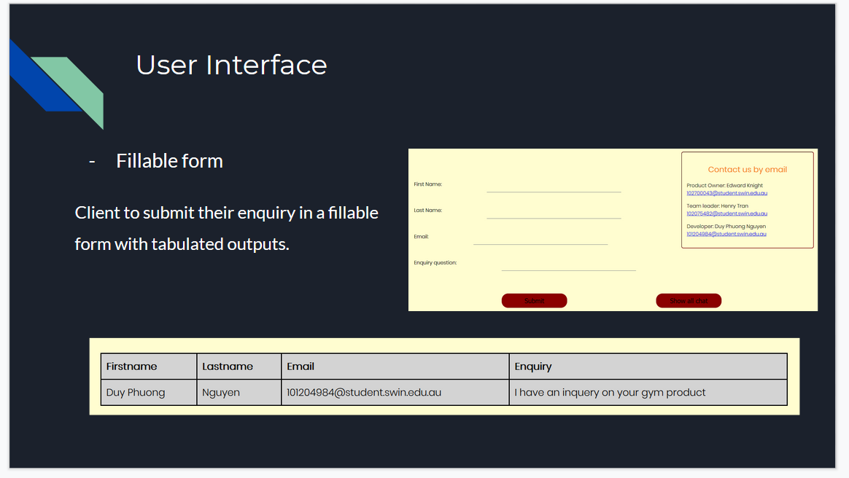

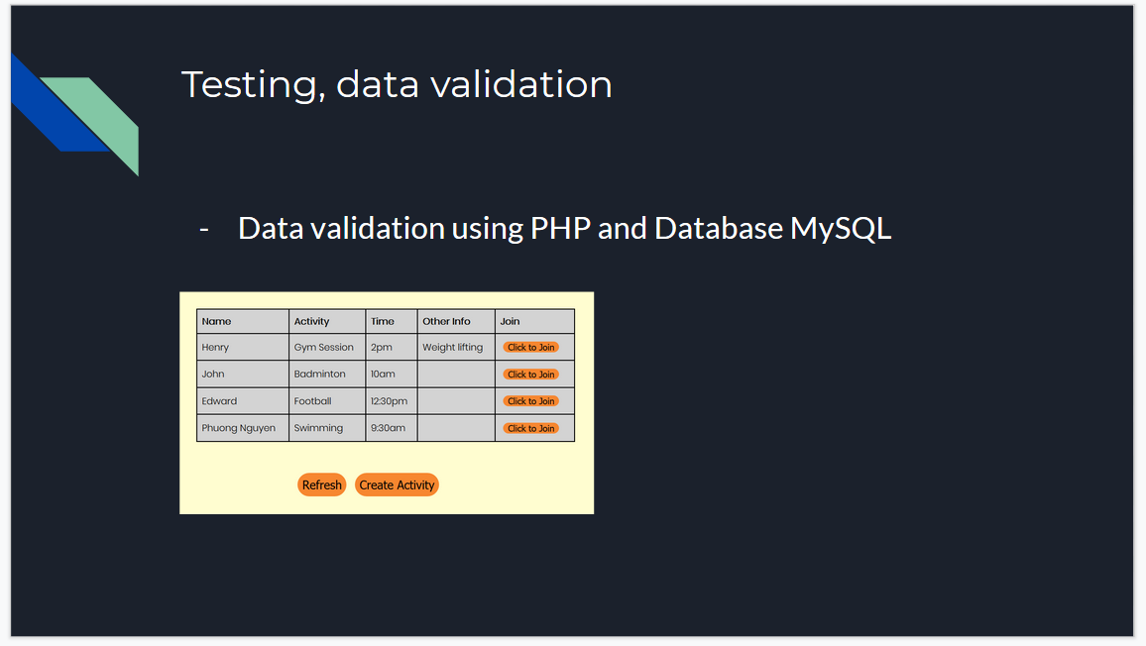

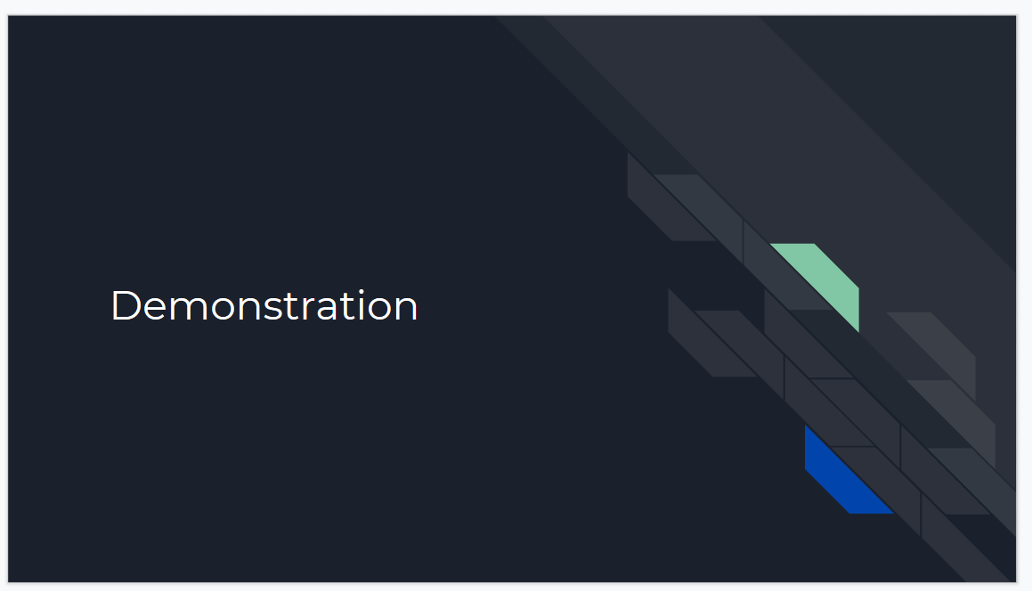

Henry sent me his works.

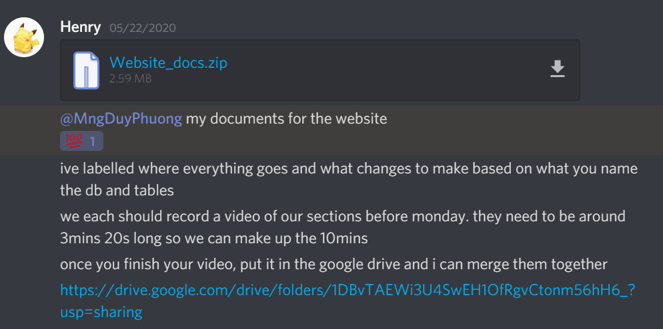

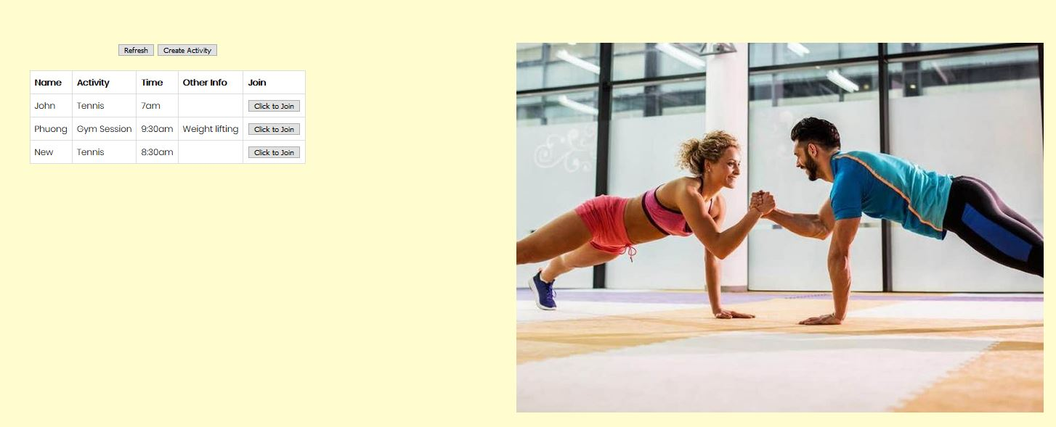

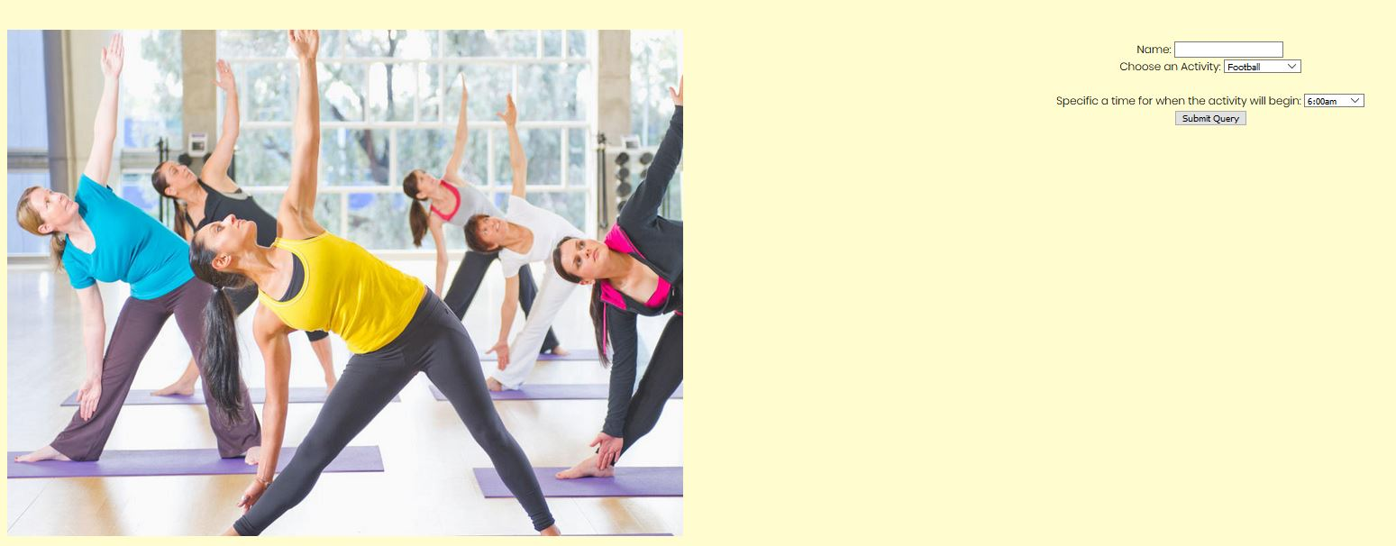

I think it can look better so I changed the code and design by using CSS coding.

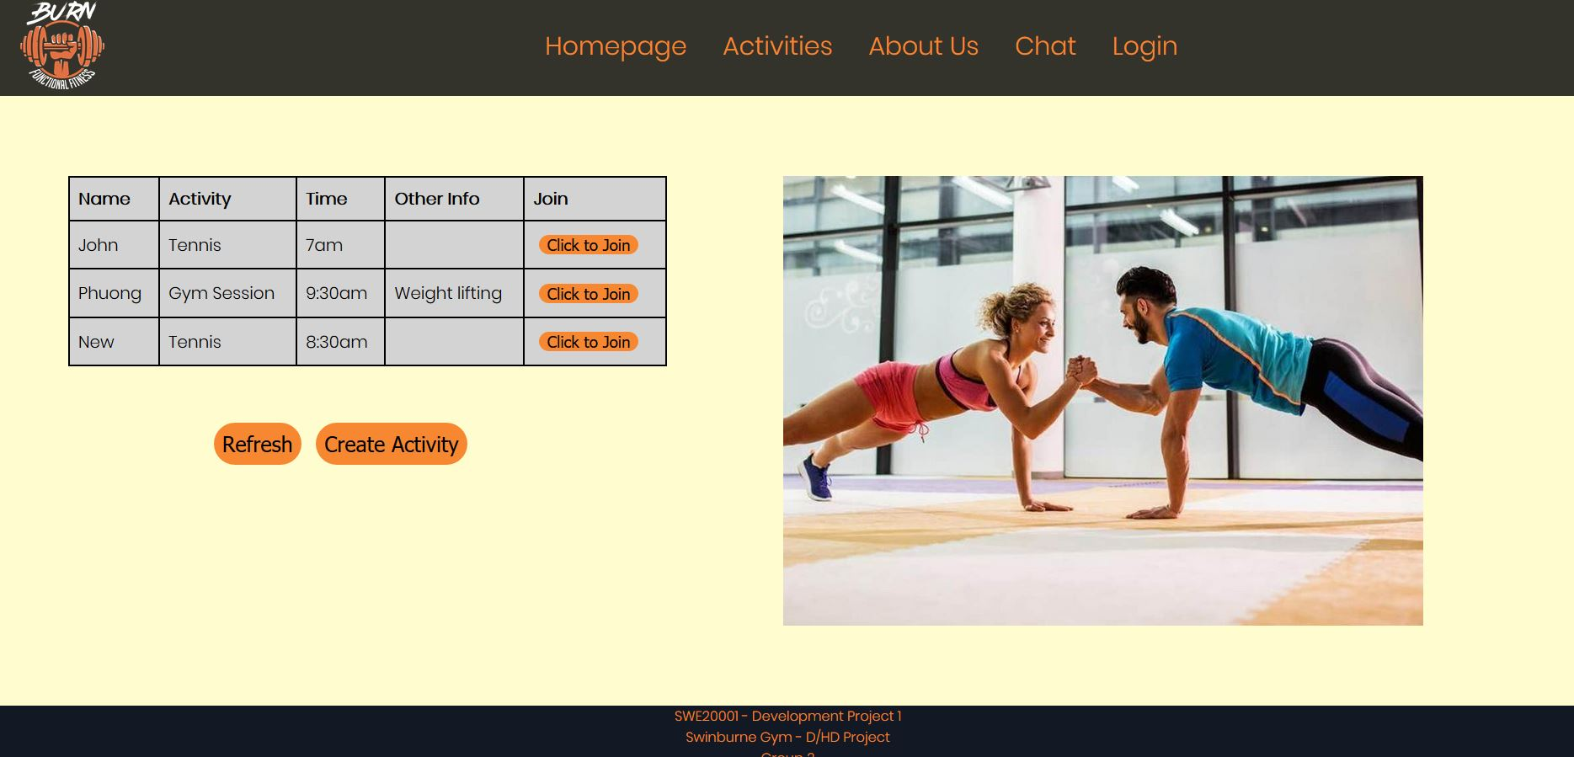

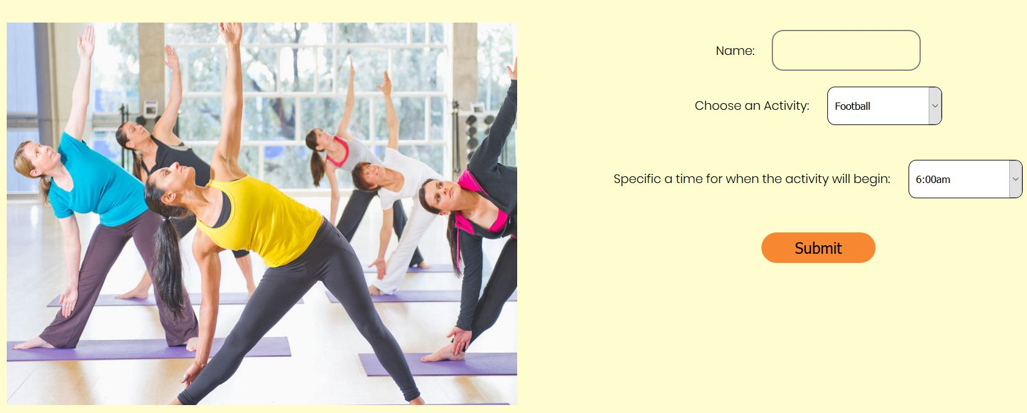

So the project is basically complete after the 2nd iteration: Develop user interface and the 3rd iteration: Create database and data validation using PHP.

Our presentation is on 26/5/2020 so I finalised everything and send it to my team member so they can check it again. I’m also ask Edward who is our product owner to help me in database function and also check our final product, write UnitTest. I write the instruction carefully so he can easy to understand and how to the code works.

However, he doesn’t care about this project that much, he did not reply me and refuse to help. I’m a bit tired with all the workload I got so I decided to stop there.

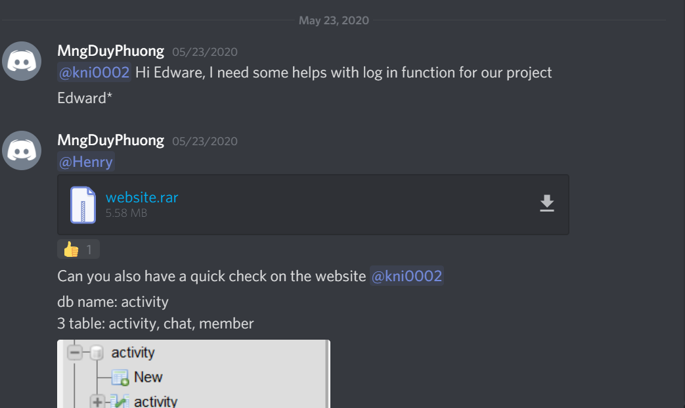

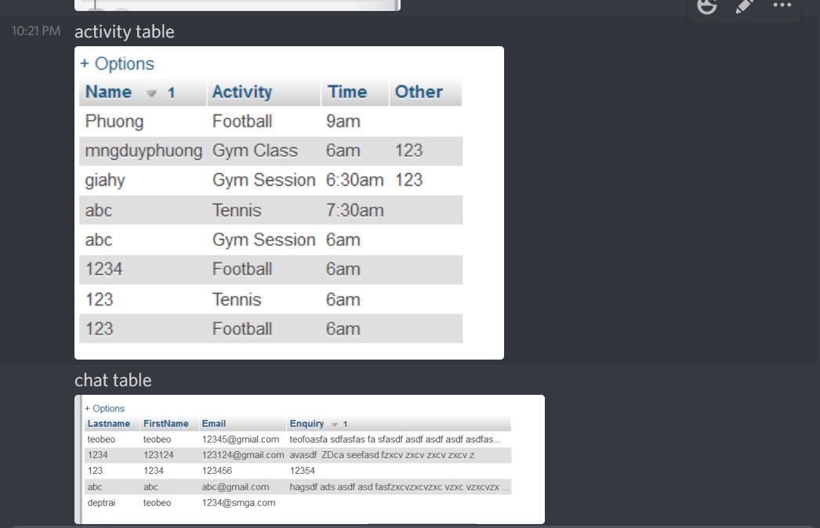

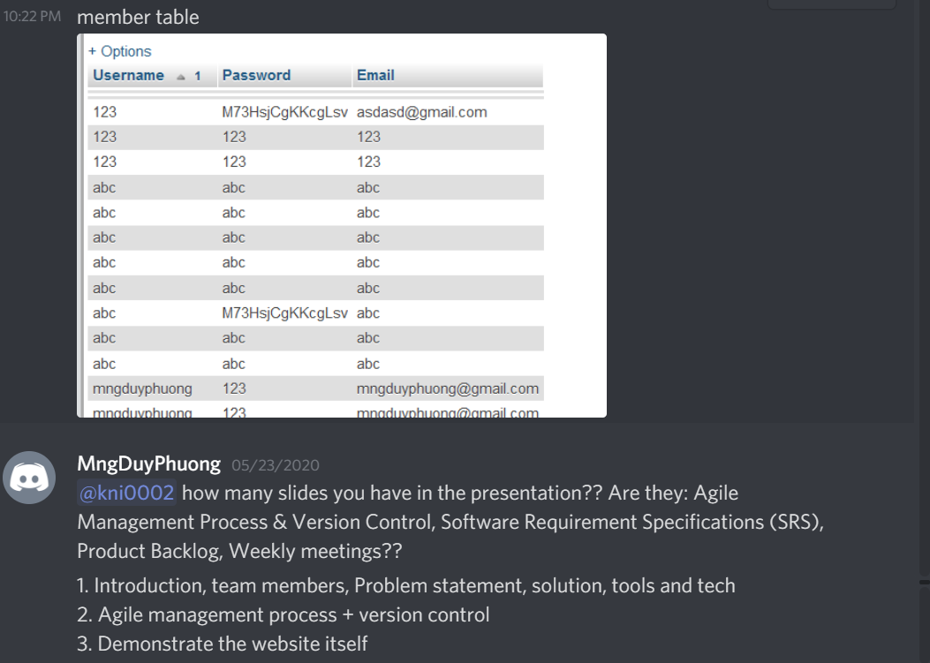

I uploaded my videos to team leaders and ask him to merge my works.

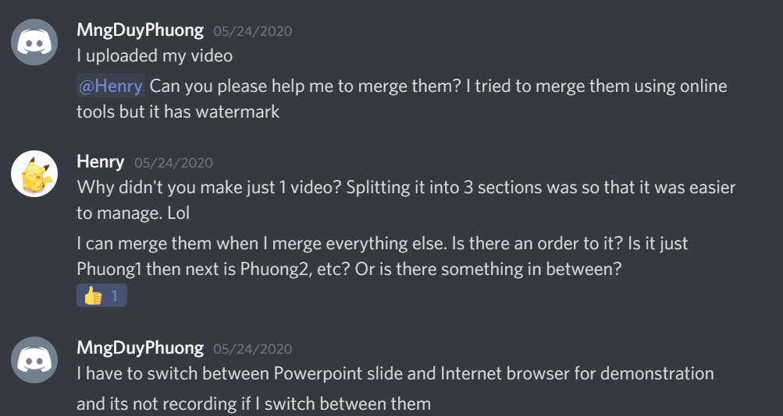

Our presentation video is due on 25/5/2020 12:30pm. However, Edward did not submit his video on time, and we missed the deadline.

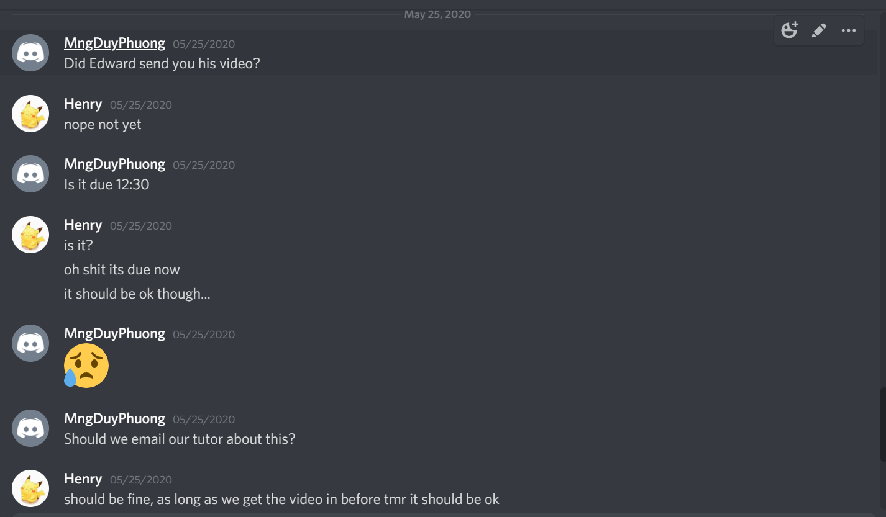

We tried to call him, text him but still no reply from him until 2:30pm, which is late for 2 hours

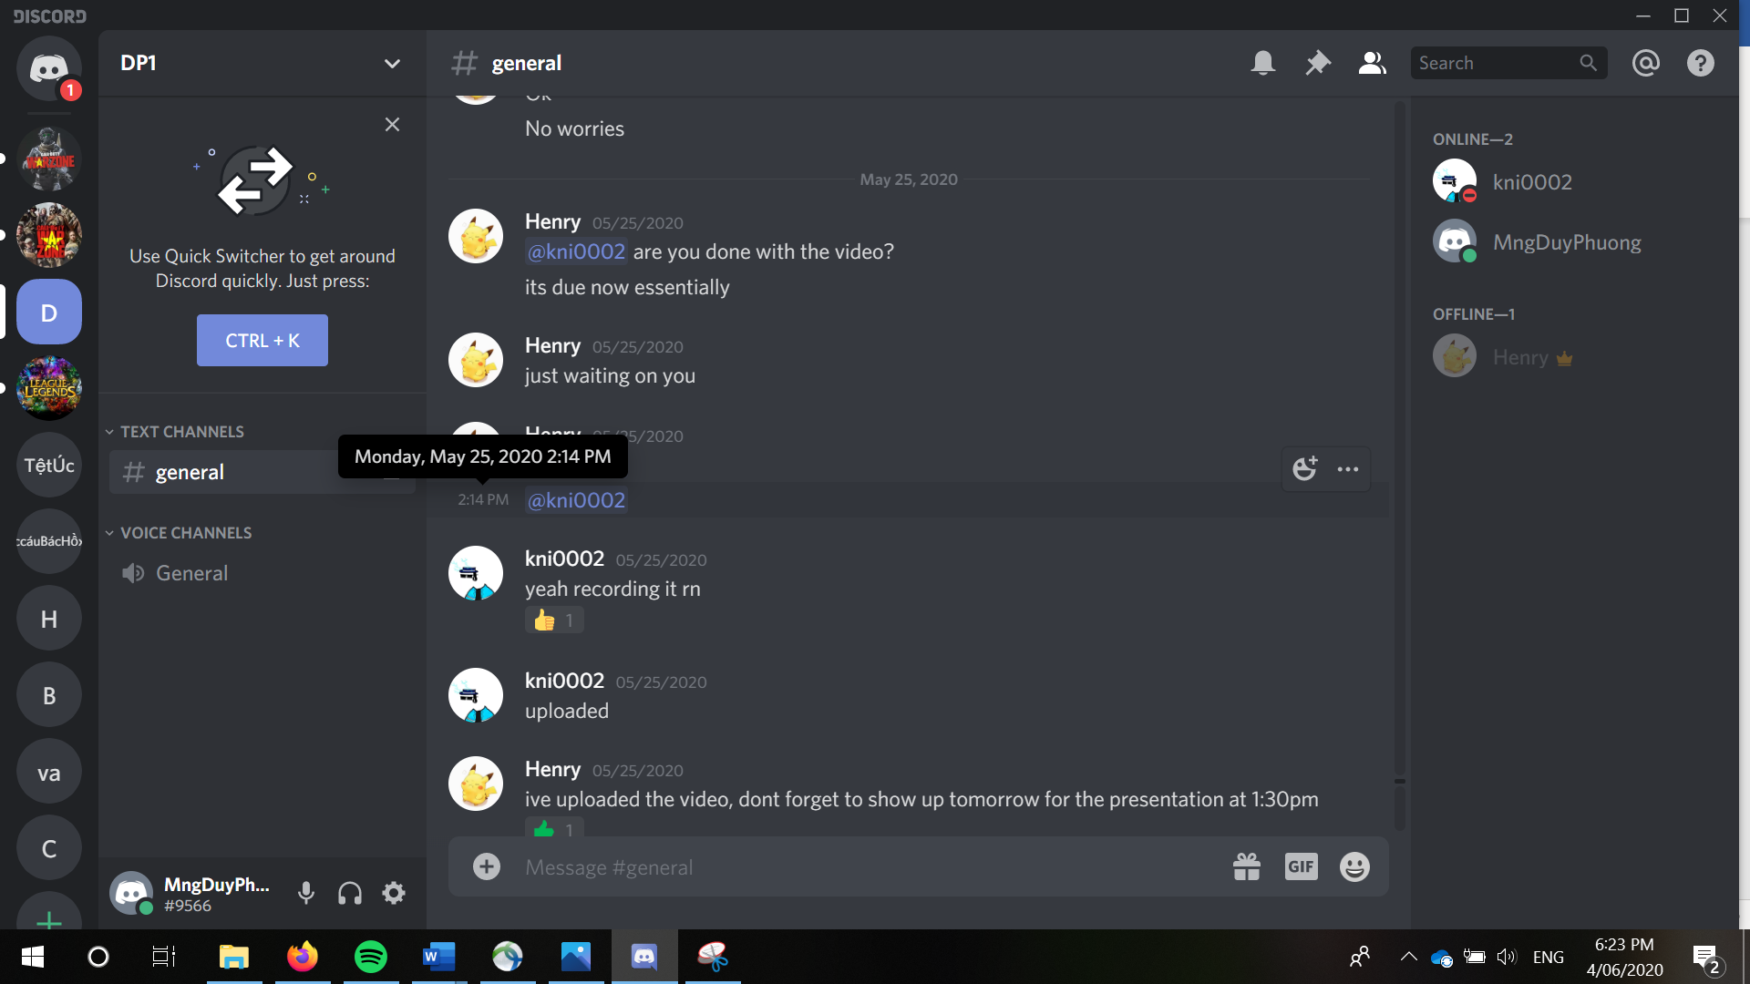

## The online location or included report of detailed contribution activity.

Discord channel: <https://discord.gg/XnjP8qe>

Trello board: <https://trello.com/invite/b/F5bzZg91/d1af2e036ca03440f7573e8060d91c02/d-hd-project>

Project vision document: <https://docs.google.com/document/d/1SUqZLmlUQg9dPGTYAZMrN3iHSsnp4V8JcTqsu7K69r4/edit?usp=sharing>

Presentation slides: <https://docs.google.com/presentation/d/1i5ihImtHBmKhtRiNGeZL9yjshx4ihXj_3MBA3UzlOVc/edit?usp=sharing>

Meeting minutes: <https://docs.google.com/document/d/1yOgk-_9Y_MMMPuQJSvEN6h7hmK9QzMBvAbpE_LMOm5M/edit?usp=sharing>

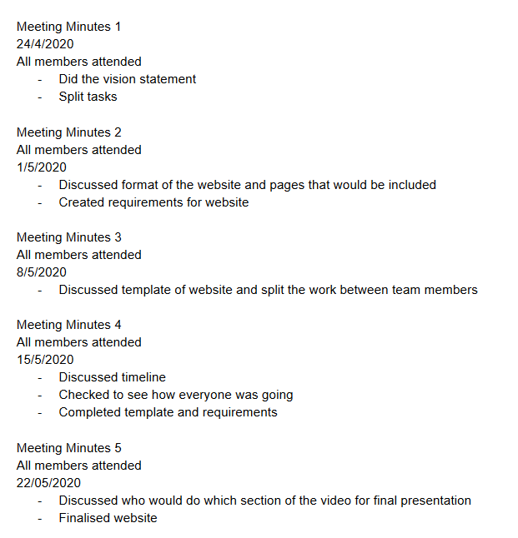

## Reflection and detailed comment on the practices and tools used in the project and how they contributed to the effectiveness of the team and the project outcomes

Our group mainly use discord channel to transfer and merging the file manually, so we don’t have many detailed reports to provide and this is not good. I tried to ask my team to use GitHub and GitBash for Merging, Submitting the project and they refused.

Discord is a very good tool because we use it to discuss and voice chatting during COVID-19 without meeting face-to-face.

Trello board is also very helpful in splitting the task and tracking member’s progress.

However, in my opinion the teamwork experience is not that good. We have a smaller team which is only 3 members while other teams have 4-5 members so they definitely has better quality product. Also in our group, our product owner Edward does not contribute enough to the project. All he did is the SRS which is only 987 words. Me and Henry have to do more works to finish the project on time.